Mat E 272
Fall 2001 – Lecture 2

General Background (definitions, fundamental tools)

Metals: Materials characterized by high density of de-localized electrons (metallic bonding)
Examples: Cu, Zn, Fe, Ti, Ag, Pt, brass, steel, monel,…

Ceramics: Materials characterized by covalent &/or ionic bonding
Examples: silica (quartz), alumina, silicon carbide

Polymers: Organic materials, generally consisting of covalently-bonded hydrocarbons
Examples: nylon, polystyrene, polyethylene, polyester

 | POLYMERS | CERAMICS | METALS
DUCTILITY | Varies | Poor | good
CONDUCTIVITY (ELECTRICAL & THERMAL) | Low | Low | High
HARDNESS/STRENGTH | Low – medium | Very high | Medium – high
CORROSION RESISTANCE | Fair – good | Good | Fair – poor
STIFFNESS | Low | High | Fair
FRACTURE TOUGHNESS | Low – medium | Low | High
MACHINABILITY | Good | Poor | good

Composites: Materials consisting of more than one distinct phase or component
- many different types (metal – metal, ceramic – polymer, metal –ceramic, metal – polymer, ceramic – ceramic)
- can have high or low conductivities
- engineered for specific applications (high strength – low density, high strength – high conductivity, etc.)
- usually strong (by design) (fiberglass: glass fibers → strength and polymer matrix → formability)
- may or may not be deformable

Semiconductors: Materials characterized by electronic conduction intermediate between metals and ceramics (e.g., Si, Ge, GaAs, InP)

Some definitions:

Atomic number: (Z)
Identifies the type of element.
= # protons in nucleus (H = 1, He = 2, B = 5, O = 8, Sn = 50, etc.)
(also = # electrons in the neutral atom)

Mole: name given to 6.023 x 10²³ things
Usually used in context with atoms or molecules
More formally: “the amount of substance that contains as many elementary entities as there are atoms in 12.011 grams of carbon ${}_{6}^{\text{12}}{}C$.”
Avagadro’s
Number: N_{a} = 6.023 x 10²³ (# atoms in one mole of substance)

Atomic mass: (A) = mass of protons + neutrons in nucleus
usually given in mass per mole (or, mass of 6.023 x 10²³ atoms)
examples:
H: 1.0080 g/mole
C: 12.011 g/mole
O: 15.999 g/mole
Si: 28.086 g/mole
Fe: 55.847 g/mole
Au: 196.97 g/mole
Pb: 207.19 g/mole

Useful tip: many problems can be worked by suitable manipulation of density (g/cm^3), atomic mass (g/mole), and Avagadro’s number (atoms/mole) (use dimensional analysis!)

Example: estimate the average volume occupied by an atom in a material:

We want units of cm^3/atom:

cm^3 = cm^3 g mole = 1 at. wt. 1
atom g mole atom density N_{a}

(later, we will work “atoms/unit cell” and “volume/unit cell” into the picture)

Fundamentals of Bonding

Atomic structure:

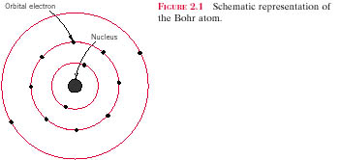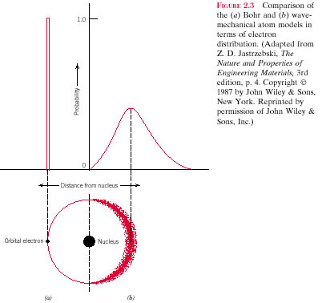Bohr model of the atom: (ca. 1913) Bohr vs. quantum mechanical model: (ca. 1927)
Based on earlier work of Rutherford and his own from spectral emission studies
Fixed, well-defined orbits. Distance of electron from the nucleus can be precisely determined.
Electron is described as a particle
Position of electron is imprecisely known; only a probability distribution. Electron exhibits both particle and wave characteristics

Electron energy levels in the atom:

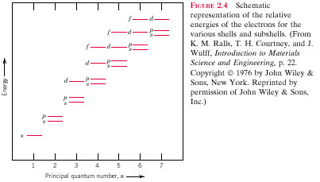
note the discrete (or quantizied) energy levels

Why study bonding?

Because the properties of materials (strength, hardness, conductivity) are determined by the manner in which atoms are connected (and also by how the atoms are arranged in space → crystal structure)

What determines the nature of the chemical bond between atoms?

Electronic structure (distribution of electrons in atomic orbitals)
Number of electrons and electronegativity (tendency for an atom to attract an electron)

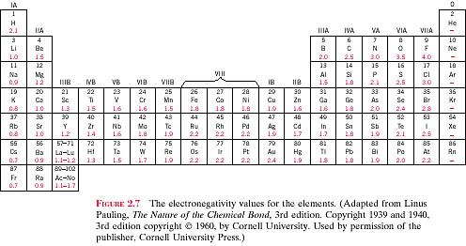

high electronegativity → strong tendency to accept an electron (i.e., Group VIIA: F, Cl)

low electronegativity (called “electropositive”) → strong tendency to give up an electron, i.e., Group IA: Li, Na, K)

(electronegativity was originally worked out by Linus Pauling in 1939 – see “The Nature of the Chemical Bond”)

the difference in electronegativity between two atoms determines the resulting electron distribution and the type of bond

Equilibrium separation between atoms:
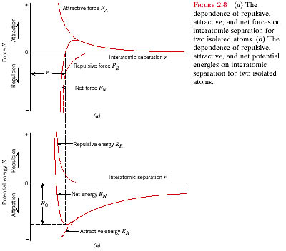$E=\int{F⋅\text{dr}}$
Net force is given by the sum of a (weak, long range) attractive force and a (strong, short range) repulsive force

Note: dF/dr → modulus of elasticity (stiffness)
Potential is given by the integral of the net force curve with respect to distance:

Note: equilibrium separation occurs where the net force = 0

Note ASYMMETRY of the potential vs. distance curve

(due to differing relative strengths of the attractive and repulsive forces)
(THIS IS THE REASON FOR THERMAL EXPANSION)

(slope of force vs. distance curve at equilibrium separation = modulus of elasticity)

Bonding energy: Minimum of the potential vs. distance curve
Indicates how much energy must be supplied to completely disassociate the two atoms
Depth of the potential well indicates bonding strength
Deep well → strongly bonded
Shallow well → weakly bonded

Q: What can you infer about a material’s melting temperature from the depth of the potential curve?

Bonding types

- Ionic: electron transfer from one atom (cation) to the other (anion)
More likely between atoms with large electronegativity differences
Typically found between metal and non-metal atoms:

NaCl, KF, CsBr, MgO

Charge transfer results in electrostatic attraction between cations and anions:
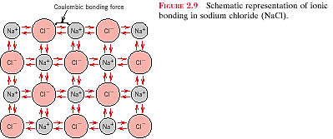

Typical bonding energies: 600 to 1500 KJ/mole (3 to 8 eV/atom)

Typical characteristics of ionically-bonded materials:
High melting temperature
Hard
Brittle
Insulator (electrical and thermal)

- Covalent: electron sharing between atoms
Each atom contributes (at least) one electron to the bond
Tends to be a highly directional bond
Gives rise to a fixed orientation of the atoms
Shared electrons may be considered to belong to each atom
Each atom tries to achieve a more stable orbital filling configuration

Found in such diverse materials as diamond, silicon, SiC, GaAs, H₂O, & many organic compounds (CH₄, HNO₃, HF)

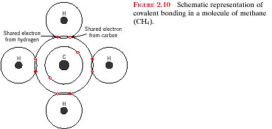
Example of a covalently-bonded substance: methane (CH₄). Note the sharing of 4-2p C electrons and 4-1s H electrons to complete a filled orbital (the “L” shell).

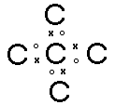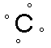Note how the sharing of electrons acts to complete the filling of electronic states in each respective atom:
Carbon:
1s²(2s²2p²) → 1s²(2s²2p⁶)

Difficult to assign general characteristics to covalently-bonded materials:

Bonds may be strong (diamond, T_{m} > 3550°C) or weak (Bi, T_{m} = 270°C)
Materials may be conductive (GaAs) or insulating (diamond)

MOST MATERIALS ARE NEITHER 100% IONIC NOR 100% COVALENT

% ionic character = $[1−\text{exp}\left\{−0\text{.}\text{25}(X_{A}−X_{B})^{2}\right\}]$ x 100%, where X_{A}, X_{B} are the electronegativities of the A and B atoms, respectively.

Examples:

For TiO2, XTi = 1.5 and XO = 3.5, and therefore,

%IC = x 100 = 63.2%

For ZnTe, XZn = 1.6 and XTe = 2.1, and therefore,

%IC = x 100 = 6.1%

For CsCl, XCs = 0.7 and XCl = 3.0, and therefore,

%IC = x 100 = 73.4%

For InSb, XIn = 1.7 and XSb = 1.9, and therefore,

%IC = x 100 = 1.0%

For MgCl2, XMg = 1.2 and XCl = 3.0, and therefore,

%IC = x 100 = 55.5%

- Metallic: Third primary type of bonding – found (not surprisingly) in metal systems.

Valence electrons are not bound to any specific atom…
… but are “free” to drift throughout the material (subject to local and external electromagnetic fields)

Active bonding electrons form an “electron sea”

Positively charged ion cores are held together by electrostatic attraction to the electron sea

An illustration of metallic bonding:
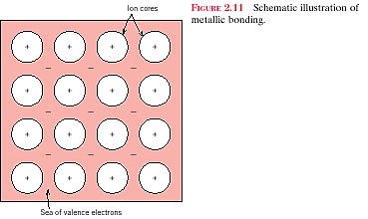

Metallic bonding can be either weak (68 kJ/mole or 0.7 eV/atom for Hg) or strong (850 kJ/mole or 8.8 eV/atom for W)

Metallic bonding gives rise to high electrical and thermal conductivity

Metallic bonding also gives rise to ductility (at least more than in most covalent and ionic solids) Think about why this might be so.

Secondary bonding (~ 10 kJ/mole or 0.1 eV/atom)

Also referred to as Van der Waals bonding

Ionic, covalent, and metallic are examples of primary bonding

Other bonding mechanisms exist, which tend to be less strong than the primary bonding types
Compare typical secondary bonding strengths (10 kJ/mole) with typical primary bonding strengths (50 to 1000 kJ/mole)

Van der Waals bonding is always present, but obscured if primary bonds exist

Basis for Van der Waals bonding → charge polarization (dipoles):

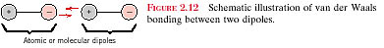

Atoms or molecules are normally electrically symmetric

Centers of positive and negative charge coincide

Thermal vibration fluctuations can disrupt charge symmetry…
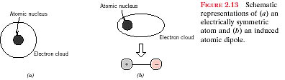

…which leads to a dipole. The presence of one dipole can induce a dipole in an adjacent molecule (or atom) and so on.

The magnitude of the Van der Waals can vary with time due to the presence of thermal fluctuations

(Secondary bonding is responsible for agglomeration of ultra-fine particles in suspension)

Some molecules possess permanent electric dipoles (e.g., HCl)

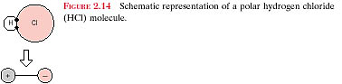 This is generally due to asymmetrical bonding

These are called POLAR molecules

Examples of polar molecules: water, ammonia, hydrogen fluoride

Hydrogen bonding is a special case of secondary bonding

Occurs between many molecules having hydrogen as a constituent

(Note: The intermolecular bonding for HF is hydrogen, whereas for HCl, the intermolecular bonding is van der Waals. The hydrogen bond is generally stronger than van der Waals, therefore, we expect HF to have a higher melting temperature.)

A comparison of the type of bonding found in different materials:

For brass, the bonding is metallic since it is a metal alloy.

For rubber, the bonding is covalent with some van der Waals. (Rubber is composed primarily of carbon and hydrogen atoms.)

For BaS, the bonding is predominantly ionic (but with some covalent character) on the basis of the relative positions of Ba and S in the periodic table.

For solid xenon, the bonding is van der Waals since xenon is an inert gas.

For bronze, the bonding is metallic since it is a metal alloy (composed of copper and tin).

For nylon, the bonding is covalent with perhaps some van der Waals. (Nylon is composed primarily of carbon and hydrogen.)

For AlP the bonding is predominantly covalent (but with some ionic character) on the basis of the relative positions of Al and P in the periodic table.

Next time: crystal structure, lattice directions and planes

